

UNAVCO Campaign GPS Handbook

January 2010

INTRODUCTION ………………………………………… 1

THE BASICS ………………………………………… 2
- Scientific applications ………………………………………… 2
- Basic positioning ………………………………………… 3
- Survey styles ………………………………………… 5
- Reference frames ………………………………………… 7

SURVEY RESOURCES ………………………………………… 8
- Reference stations ………………………………………… 8
- Logsheets and field notes ………………………………………… 9

SURVEYING ………………………………………… 10
- Equipment ………………………………………… 10
- Monumentation ………………………………………… 11
- Antenna mounts ………………………………………… 12
- Receiver configuration ………………………………………… 13
- Power ………………………………………… 14

POST-SURVEY ………………………………………… 15
- Data downloading and backup ..………………………………… 15
- Data formats ………………………………………… 15
- Data processing ………………………………………… 17
- Data archiving and data access ………………………………… 19

WORKING WITH UNAVCO ………………………………………… 20

INTRODUCTION

This handbook is designed to introduce users to campaign GPS surveying with high-precision GPS equipment and to the related services offered by UNAVCO. The document outlines execution of a GPS campaign from survey planning to general surveying methods to documentation, data processing, and data archiving.

This document is intended as an introduction to be used prior to training by a UNAVCO field engineer, as an outline to be used during the UNAVCO training, as a reference guide after completing the UNAVCO training, and as a refresher for those with previous GPS surveying experience. It also serves as a general GPS primer for scientists who are considering using GPS in their research.

Note that this handbook is not tailored to a specific application or to specific equipment; application- and equipment-specific training is offered on-demand, typically over the course of three days and with one or two students per instructor. Equipment-specific resources can also be found on the UNAVCO Facility Knowledgebase at http://facility.unavco.org/kb.

To request training or for questions not addressed here, e-mail support@unavco.org.

These are the questions to ask while preparing for a campaign survey:

1) What are the survey goals? This will determine the survey style and, to a lesser extent, the monumentation and mounts used. This will also determine your data processing needs.

2) What is the survey geography and geometry? How large an area with the survey cover, and what is the terrain like? Is there good sky view? Are survey points visible to the base station, if there is one (for RTK surveys only)?

3) What resources are available to you? Is there already a GPS site running in the region? Will you be traveling by car, helicopter, or other—are weight and space an issue? What are your power options in the field (and, what is the climate? Batteries drain much more quickly in the cold).

Keep these questions in mind as you move through the rest of this handbook.
BACKGROUND

1. Scientific applications

The geodetic community has long recognized the scientific applications of GPS. High-precision GPS has been used since the mid-1980s for measuring relative tectonic plate motions (Figure 1a), isostatic adjustment (Figure 1b), motions along and across faults (Figure 1c), and volcanic motions. From these measurements, researchers have calculated strain rates, mantle viscosity, locking depths of faults, and more. GPS can also be used to map and to navigate back to sample locations, to measure glacier velocities (Figure 1d), and to monitor landslides. As technology advances and prices come down, high-precision GPS instruments for scientific applications are becoming more affordable, lighter, more power-efficient, and with memory better suited for long-term applications. Because of this, the scientific GPS user community is expanding and the demand for longer, larger campaigns is increasing.

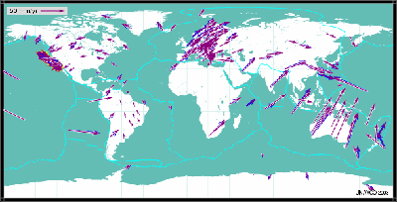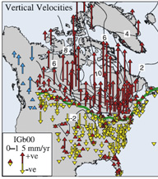

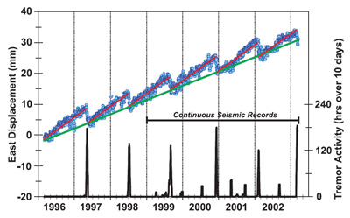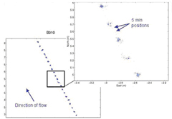
Figure 1: Examples of scientific applications of GPS/GNSS. a) Global tectonics: composite GPS Velocity Map showing global tectonic motions. Generated in UNAVCO’s interactive Voyager map tool. b) Glacial isostatic adjustment: vertical GPS site motions in North America; note large uplift rates around Hudson Bay, where the crust is thought to be rebounding from the effect of glacial loading. c) Earthquake and fault dynamics: plot of the change in longitudinal position of a GPS site in the Pacific Northwest as it responds to episodic tremor and slip along the Cascadia subduction zone. d) Glacier flow: Horizontal positions at 5-minute intervals on Whillans Ice Stream, Antarctica; upper inset shows enlargement of five slip events. For more info on these data sources and other science applications of GPS, see http://www.unavco.org/research_science/science-apps/science-apps.html.
2. Basic positioning
GPS positioning is based on triangulation from GPS satellites in precisely defined orbits. Each of the 24 to 27 active GPS satellites transmits a unique code modulated onto a carrier frequency (Figure 2). The receiver generates the same codes at the same time as the satellites; by measuring the offset between the code generated and the code received, the receiver can determine the time the signal took to travel and therefore calculate the rough distance to each satellite (distance = velocity x time, where velocity for a radio wave is the speed of light). [Note that the velocity of the radio wave may vary as it travels through different medium, such as the Earth’s atmosphere, thus introducing error into the measurements.] By receiving data from multiple satellites, a single GPS receiver can pinpoint its position to within a few meters (Figure 3). Four satellites are the minimum required for the receiver to solve for the four unknowns: x, y, z and time (receiver clock error).

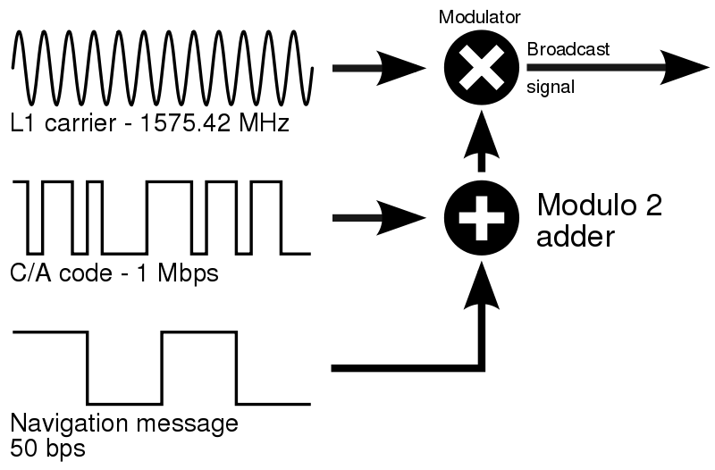






Figure 2: Visualization of the carrier frequency (sine Figure 3: By calculating the intersection points of spheres of
wave) and the codes modulated onto it. a given radius (the distance from each satellite to our GPS
antenna) around satellites 1, 2, and 3, we can determine our
location. Note that using three satellites we end up with two
points of intersection; one can be eliminated by using the
Earth as a third sphere. However, a fourth satellite is still
needed to calculate receiver clock errors.

High-precision results (< several cm) require equipment and data processing methods not available in hand-held GPS units. Equipment (receiver, antenna), survey design (using two or more systems simultaneously), and processing all contribute to high-precision GPS. The receivers track multiple satellite frequencies (rather than just the L1 frequency) and use not the codes but the carrier frequency (Figure 2), which has a shorter wavelength, to measure the distance to satellites. This adds the complication of estimating the number of sine waves between the receiver and the satellites, called the ambiguity, but yields better measurements. The antennas are designed to minimize signal noise such as multipath, signals bounced off reflectors rather than direct arrivals. By comparing simultaneously-collected data from two or more GPS instruments, satellite clock errors are solved for and eliminated. In surveys where survey points are close together (< 10 km), many error sources are shared and can be greatly minimized or eliminated from each solution (Figure 4). This method is called ‘differential GPS.’ And, by processing the data after collection, precise orbital information (satellite ephemeris) are applied, the signal-delaying effects of the troposphere are modeled and those of the ionosphere are eliminated with the use of two or more satellite frequencies.

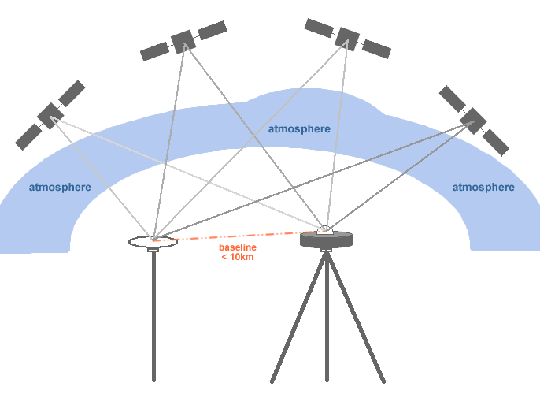
Figure 4: Diagram of differential GPS. The base station, on the right, is set up over a known point. Because the base station and the rover (on the left) are close together, they share many error sources. For example, the signals from each satellite travel through essentially the same atmosphere to get to each GPS antenna. This results in a precisely determined baseline between the two antennas. If the base coordinates are known within a chosen coordinate system, the rover coordinates can be determined with accuracy as well.

Note the difference between accuracy (‘correctness’) and precision (repeatability), and relative vs. absolute. GPS measurements yield high-precision, that is, highly-repeatable, baselines (the distance and azimuth between points). For measurements to be accurate, base location coordinates must be accurate (correct) within a particular reference frame; then the rover coordinates will be accurate within that reference frame as well. Think of it this way: GPS provides very good relative measurements (one GPS measurement relative to another, so long as there is at lease one instruments recording continuously throughout the survey) but not necessarily good absolute measurements—for this, post-processing is needed. So, baseline precision does not imply coordinate accuracy unless the initial starting coordinates are of a known high quality. Often, we are more interested in how sites are moving relative to each other, for which high precision is sufficient, than we are in exactly where the sites are. For example, how are the sites on the Pacific plate moving relative to the sites on the North American plate? We choose sites on either side of the San Andreas fault to answer this question. We don’t care exactly where the sites are; we care how they are moving relative to each other. This is a strength of GPS and the reason we always look at where GPS measurements are relative to other GPS measurements.

If you are new to GPS and want to know more, check out Trimble’s online tutorial at http://www.trimble.com/gps/. For a more detailed description of how GPS works and its high-precision applications, see, for example, Dixon, T.H., An introduction to the Global Positioning System and some geological applications, Rev. Geophys., 29, 249-276, 1991.

3. Survey styles
Various methods are used to collect high precision GPS data. The particular method used depends on several factors, including survey objectives, desired precision, available equipment, and field logistics. Higher precision typically requires a more rigorous field methodology and longer occupation times. The following table shows the features of the most common GPS survey methods:
 | Survey style | Typical accuracy | Occupation time | Typical applications
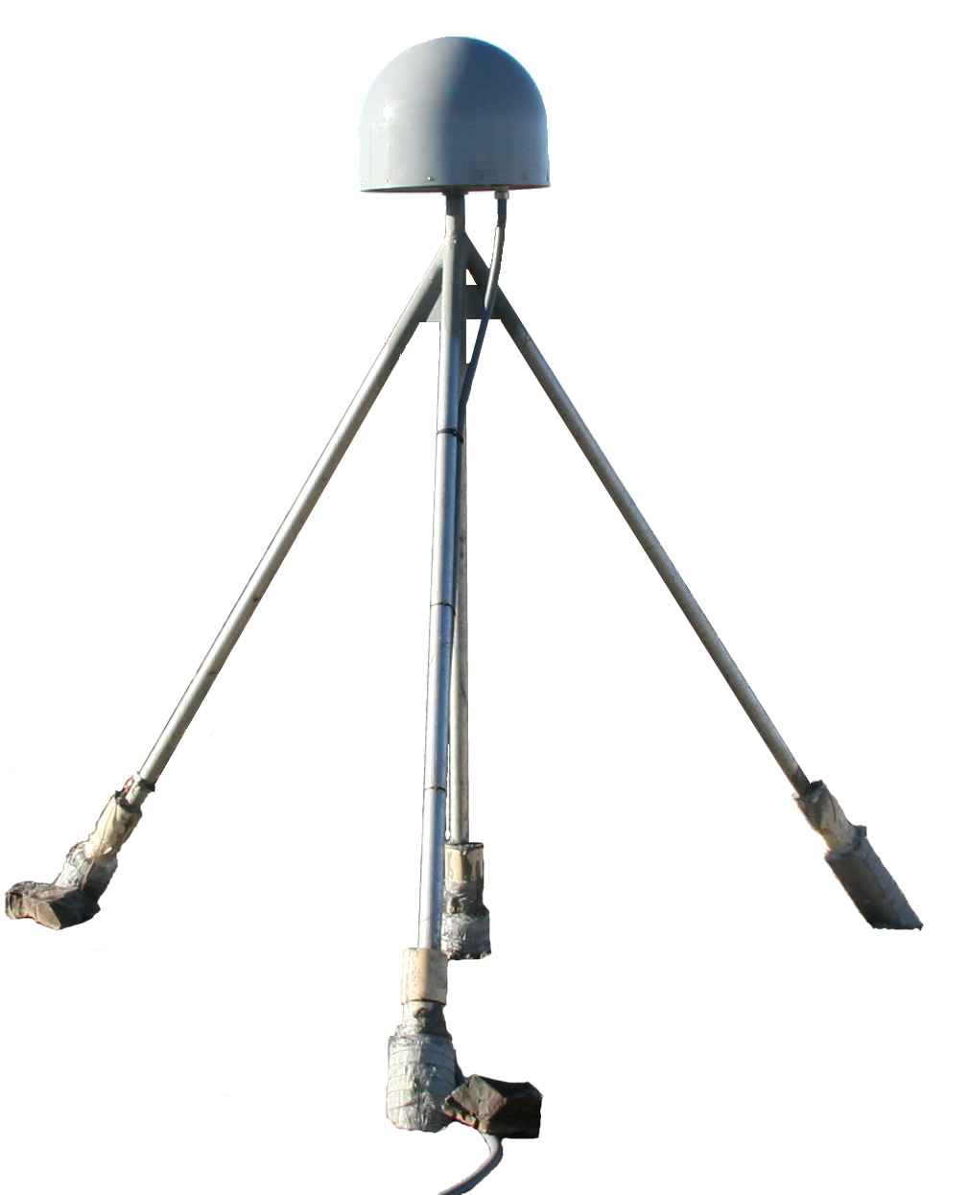 | Continuous | < 0.5 cm | Months or more | Crustal deformation, geophysics, reference stations
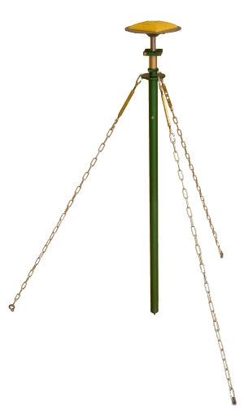 | Static | 0.5 cm – 2.5 cm | Hours to days | Crustal deformation, geodetic control, very long baseline surveys, geophysics
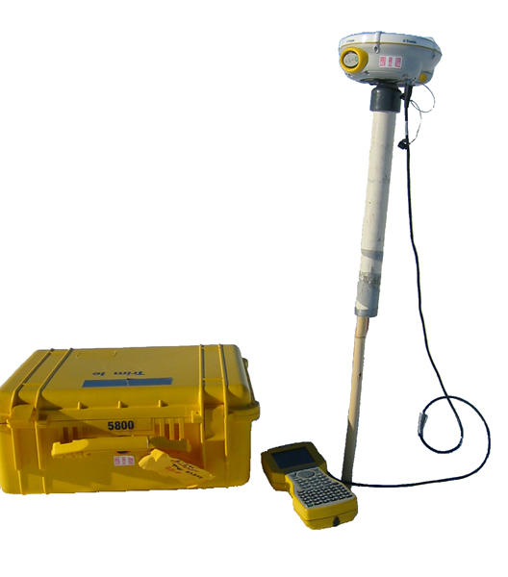 | Rapid Static | 1 cm – 3 cm | Minutes | Short baseline surveys, glaciology
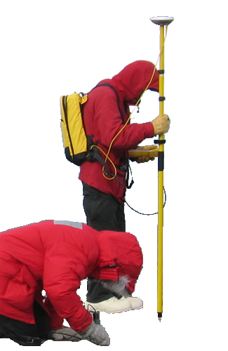 | Kinematic (post-processing and real-time) | 1 cm – 5 cm | Seconds | Short baselines, closely spaced points, vehicle positioning, feature surveys, GIS, mapping, and navigation (RTK only)
Continuous stations are continuously-operating long-term or permanent GNSS station installations involving immobile monumentation and sustainable power, and often involving data telemetry. The can be used as pre-existing base stations in campaign surveys (static, rapid static, and kinematic).
Static surveys are regional, sub-cm precision GNSS surveys with portable equipment and are the standard campaign data collection method for crustal deformation surveys. They typically involve occupying each point for several days to get the highest possible accuracy. Collect at least 6 hours of simultaneous data per day for processing and repeat benchmark occupations if possible.
Rapid static surveys are static surveys with just enough survey time at each point to be able to resolve the carrier phase integer ambiguity. A rule of thumb is to collect data for a minimum of 10 minutes per point, and add one minute of occupation time per kilometer of baseline length over 10 kilometers. For example, on an eight-kilometer baseline collect at least 10 minutes of data, and on a 28-kilometer baseline collect at least 28 minutes of data.
Kinematic surveys are local surveys (<10 km) using mobile GNSS equipment for the purpose of mapping features or of measuring point locations where several cm of precision is sufficient. At least two receiver set-ups are required: a base (stationary) unit and one or more rover (mobile) units. Kinematic surveys rely on continuous tracking to resolve the integer ambiguity; while the rover receiver/antenna may be moving during the surveys, continuous lock on the satellite signals must be maintained. Since the data processing software is able to both resolve the ambiguity and track the antenna motion, fixed-integer solutions are obtained nearly instantaneously.
Post-processing kinematic (PPK) refers to surveys without communication between the base and rover receivers. Processing the data after data collection is required. There are no navigational capabilities in PPK surveys.
Real-time kinematic (RTK) refers to surveys in which the base and rover receivers communicate corrections in real-time via a radio link. This requires additional hardware (base and rover radios) and additional power, and generally limits the survey to an area of several km, but eliminates the need for data processing and enables navigational capabilities.
Additional Survey Styles may be used in some situations.
Code differential surveys rely only on the code data to determine a differential solution. Simultaneous data collection between the base and rover receiver is still required, but there is no requirement to maintain continuous lock on the carrier phase since the phase data is not used. As a result, this method is extremely robust, but relatively coarse. For sub-meter accuracy, a rule of thumb is to collect data for five minutes per point, and add one minute of occupation time per five kilometers of baseline length over 10 kilometers. For example, on an eight-kilometer baseline collect at least five minutes of data, and on a 108-kilometer baseline collect at least 25 minutes of data.
Point positioning uses only data from a single receiver to determine its coordinates. The collected data are averaged, and longer occupations significantly increase the accuracy. This method is very coarse, but sometimes it is the only way to determine base station coordinates while in the field. Although these coordinates may be off by about a meter, it is close enough to allow the computation of precise baselines while at a remote field location. When better network accuracy is desired, the base coordinates must be re-computed when back from the field.

4. Reference frames
GPS positions are calculated in an Earth-centered, Earth-fixed Cartesian coordinate system, where the x- and y-axes are perpendicular and in the plane of the equator, and the z-axis is drawn between the north and south poles. Positions are then converted into a more user-friendly reference frame. Most commonly, positions are converted to latitude, longitude, and height referenced to a precisely defined ellipsoid, such as WGS-84. These ellipsoids are mathematical models approximating the shape of the Earth, and do not reflect the constant-gravity defined geoid (mean sea-level) surface of the Earth. As a result, the ellipsoidal elevations are usually significantly different from the corresponding geoid, or sea-level elevations. If the user is ultimately interested in geoid elevations (elevations relative to mean sea level), a geoid model such as EGM96 must be applied.

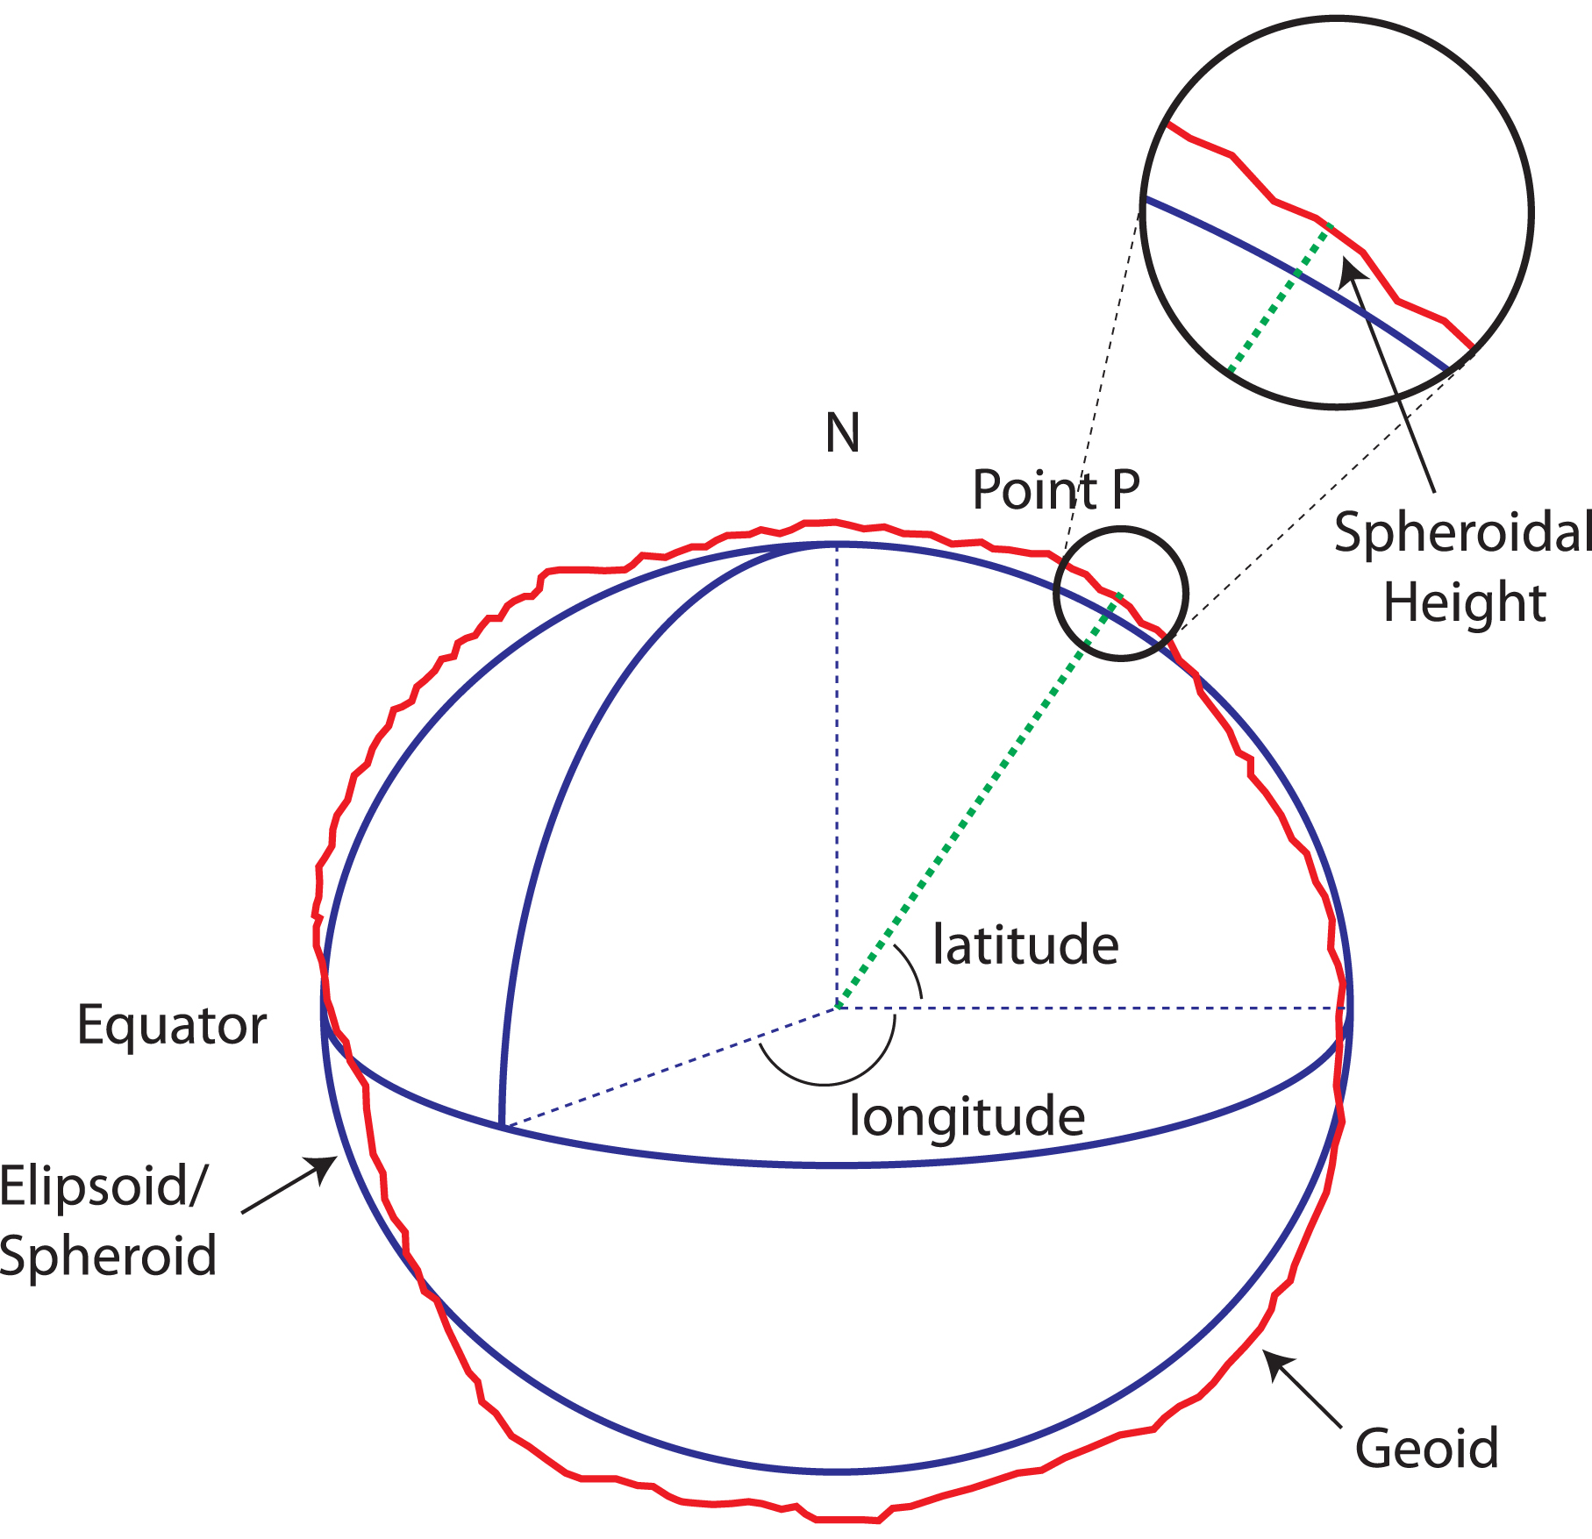

Figure 5: Schematic diagram demonstrating how the ellipsoid used in GPS coordinates does not exactly align with a consistent gravitational surface (geoid) on the Earth. Note that sea level is dependent on the Earth’s gravity, which is not constant around the globe. (From Intergovernmental Committee on Surveying & Mapping (ICSM), Australia, http://www.icsm.gov.au/mapping/datums2.html)

Horizontal positions can also be converted to northings and eastings based on a map projection. Coordinate conversions can be done in most processing software, including Trimble Geomatics Office and Topcon TOOLS.

Geodetic surveys are commonly reference to the International Terrestrial Reference Frame (ITRF), related to the International Terrestrial Reference System (ITRS). The ITRF is a reference frame defined by a set of points with their 3-dimensional Cartesian coordinates. The International Terrestrial Reference System (ITRS) is a world spatial reference system co-rotating with the Earth in its diurnal motion in space. The IERS, in charge of providing global references to the astronomical, geodetic and geophysical communities, promotes the realization of the ITRS. Realizations of the ITRS are produced by the IERS ITRS Product Center (ITRS-PC) under the name International Terrestrial Reference Frames (ITRF). That’s a lot of acronyms. For more information, see http://itrf.ensg.ign.fr/.
SURVEY RESOURCES

1. Reference stations

Global, regional, and local networks of GPS reference stations log data continuously and, in many cases, make those data freely available to the public. These data can be used as base station data for user who don’t want to, or can’t, set up their own base station, and/or can be used to tie surveys into known networks. Several large-scale networks to note are listed below. Local reference stations may also be found by contacting, for example, the county surveyor’s office.

a. IGS http://igscb.jpl.nasa.gov/
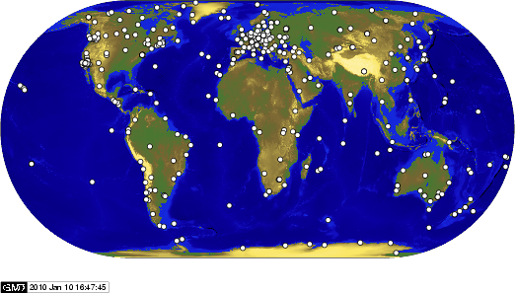
The International GNSS Service (IGS) is a voluntary federation of more than 200 worldwide agencies that pool resources and permanent GNSS station data to generate precise GNSS products. Currently the IGS includes two GNSS (Global Navigation Satellite Systems), GPS and the Russian GLONASS, and intends to incorporate future GNSS. You can think of the IGS as the highest-precision international civilian GPS community.

b. CORS http://www.ngs.noaa.gov/CORS/cors-data.html
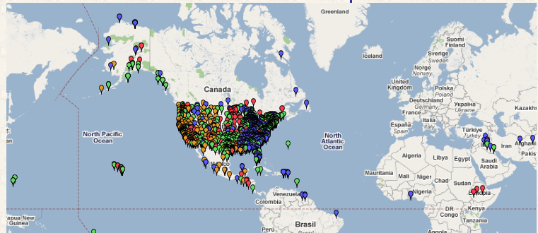
The National Geodetic Survey (NGS), an office of NOAA's National Ocean Service, coordinates two networks of continuously operating reference stations (CORS), the National CORS network and the Cooperative CORS network. Together, the networks span the United States and its territories. The CORS system enables positioning accuracies that approach a few centimeters relative to the National Spatial Reference System, both horizontally and vertically.

c. PBO http://pboweb.unavco.org/
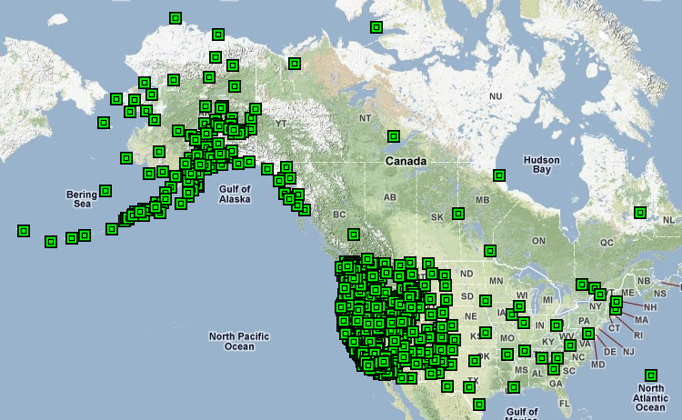
The Plate Boundary Observatory (PBO), part of the EarthScope project that is funded by the National Science Foundation, studies the three-dimensional strain field resulting from active plate boundary deformation across the Western United States. The project includes installation of over 800 continuous GPS stations throughout the Western United States, from the Pacific to the Rocky Mountains, including Alaska.

Data from many of the sites available globally and all of the sites in the Plate Boundary Observatory can be accessed through the UNAVCO Boulder Facility Archive at http://facility.unavco.org/data/data.html.

2. Logsheets and field notes

Field notes provide information about each survey point that is required to process and archive the GPS data once collected. Information on site access, monument description, sky visibility, and nearby resources should be documented when a monument is established and updated as needed. This information can be recorded on the Monument Record form. Critical survey information such as antenna height above the survey mark, GPS receiver and antenna model and serial number, benchmark identification and location, and survey start and end times are recorded on the Monument Visit Logsheet. The logsheet is required for each monument visit that is archived by UNAVCO. The ability to re-visit and meaningfully re-measure a mark, to troubleshoot data while processing, and for other groups to use the data depends strongly on the quality and accuracy of the information recorded during the survey.

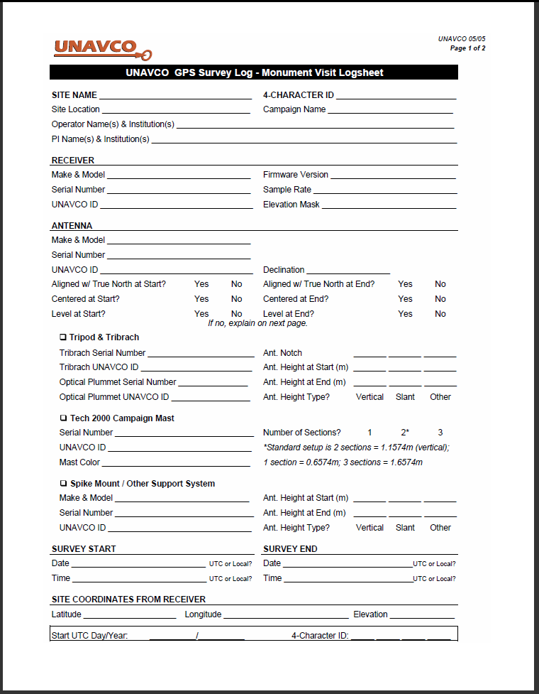
Figure 6: Monument Record form (left) and Monument Visit Logsheet (right).

Formal logsheets are not required for surveys of non-repeatable points, such as temporary glacier stakes or terrain features such as lakebed shorelines. But good field notes are still necessary for post processing of the data, and should contain site identification, data file/job name, time of survey, and antenna type, height, and measurement method.

The Monument Record form and the Monument Visit Logsheet (Figure 6) can be found the UNAVCO campaign support page at http://facility.unavco.org/kb/questions/390/.
SURVEYING

1. Equipment
High precision GPS systems consist of separate components that power the system (AC power systems, batteries and solar panels), receive the signals (the antenna), process the signals (the receiver), and store the data (the receiver and download media). The equipment used for GPS surveys is designed for use in most weather conditions and is fairly rugged. However, as with all electronics the equipment should be handled with care. While this becomes second nature to people who use the equipment regularly, it may not be obvious to new users.
Note: If you have a system, go through the different pieces and learn how to connect them and where to look for possible problems such as blown fuses or missing parts.
Proper GPS equipment handling:
- Be security conscious – theft of GPS equipment is common.
- Before doing anything with the equipment verify that the contents match the enclosed manifest.
- Check that the equipment is packed as it was received from UNAVCO.
- Use the dustcaps found on the antenna cables, receiver, and other equipment when the connectors are not in use.
- Do not force connectors when inserting or removing.
- Make sure all cable connectors are clean before making a connection.
- Do not tug on cables – this may damage the internal connection.
- Keep exposed connectors and other components away from moisture, dust, and grit.
- Keep sharp or abrasive objects away from equipment display panels and cables.
- Roll up cables to be free of kinks - do not loop cables around your arm.
- Use proper transport containers and pack them so there are no loose parts inside that may cause damage.
- Secure tripods and other antenna mounts to prevent toppling from wind gusts.
- Attend bi-pods when set up with an antenna – these can easily be toppled, resulting in antenna damage.
- Secure solar panels so they’re not picked up by the wind.
- Report any equipment problems to UNAVCO as soon as possible.
Before the equipment leaves UNAVCO, it is configured, tested and determined to be suitable for field use. For extended projects, checking the components periodically may be desired. The following checklist highlights the most important field check items:
• Configure receiver
• Verify receiver L1 and L2 continuous tracking
• Test antennas for L1 and L2 tracking
• Test antenna cables, receiver for loose connections
• Check cables for visible damage
• Charge batteries, check for extra fuses
• Check/calibrate tribrachs/rangepole levels
• Test solar panels

2. Monumentation

Various forms of monumentation can be used for surveying with GPS (Figure 7). Things to consider when establishing monumentation include precision and environment. If high precision (<1 cm), repeatable results are desired, the mark itself should be 1 mm in diameter and the marker should be durable and stable in its medium. All markers should be resistant to weathering, but the type of marker used may be dictated by land use. For example, a low-profile marker may be required in sensitive areas such as national parks. You must check with authorities or landowners before installing survey markers.

When choosing the location for a benchmark, consider what will affect the motion of the substrate. The best place for a benchmark when measuring regional tectonic motion or establishing a base station is in stable bedrock; if there is no bedrock, consider installing a concrete pier. Markers for rover set-ups can then be established in the nearby feature of interest, e.g. glacier ice, unstable slope, or ice wedges.

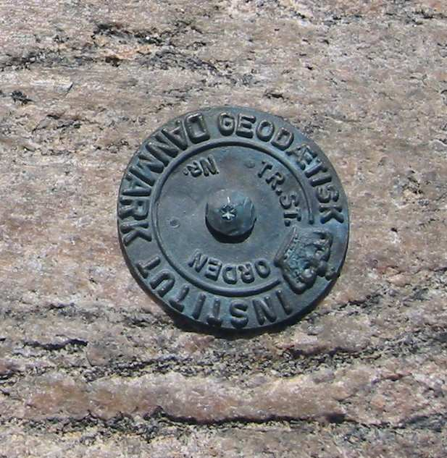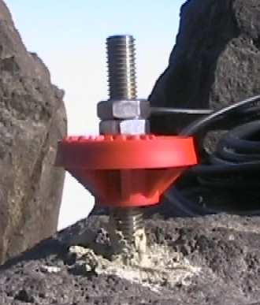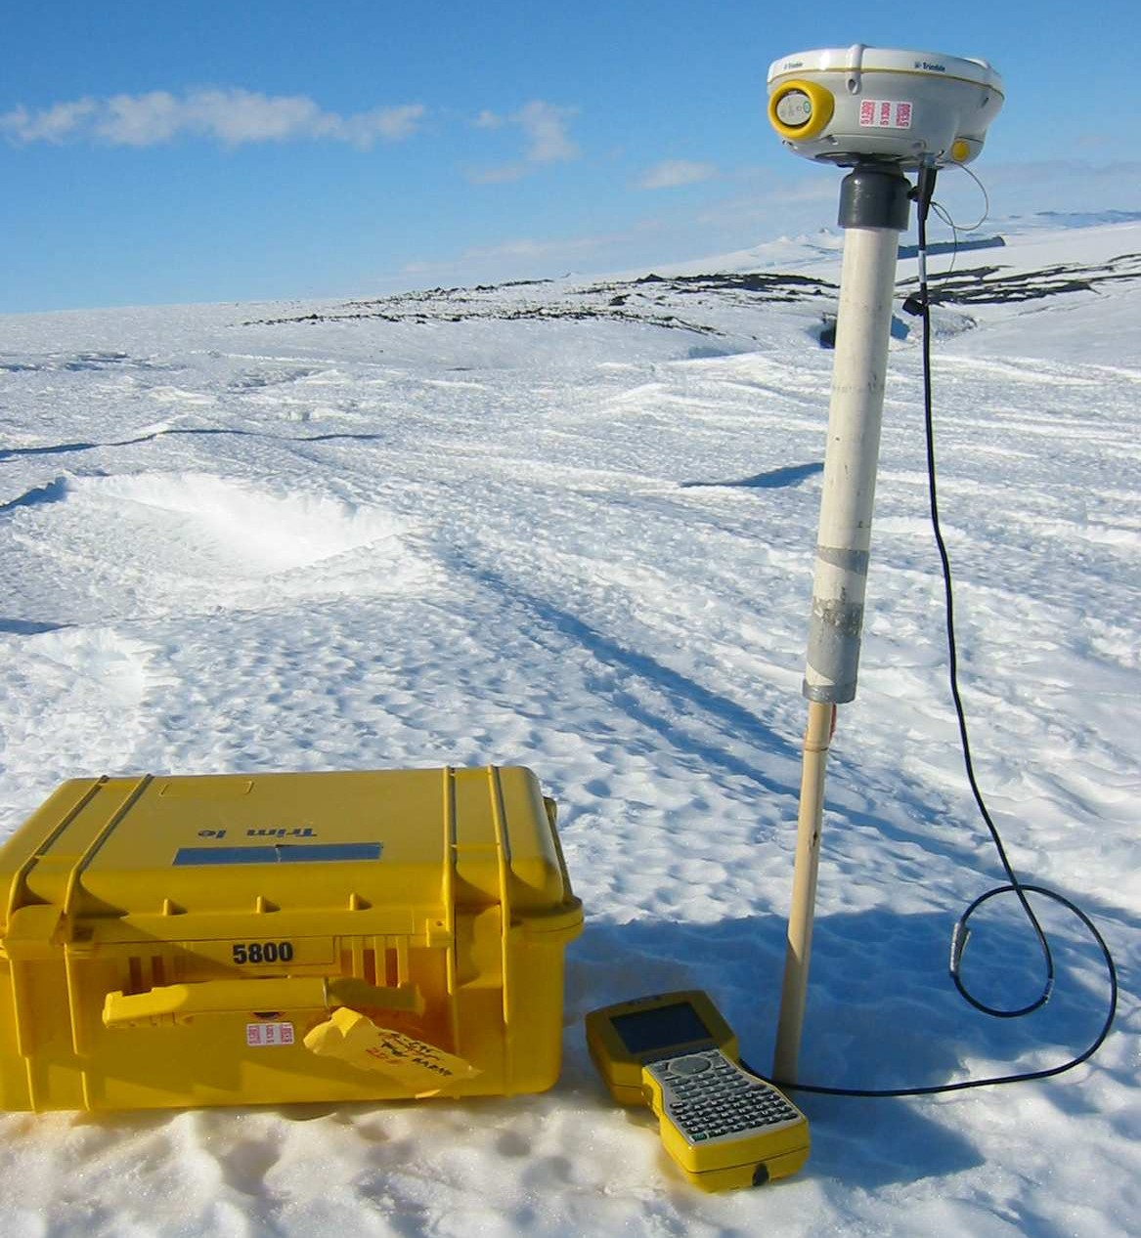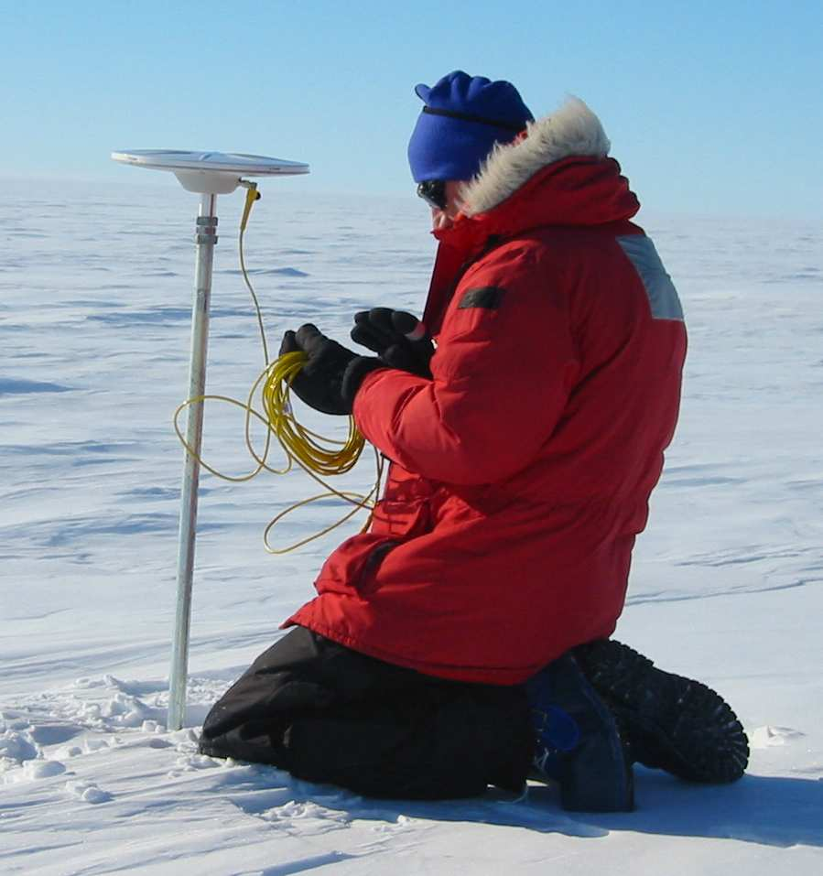
Figure 7: Examples of benchmarks. (a) A circular marker at the bedrock surface, with a pin which extends and anchors it into the rock. This mark requires a tripod, bipod, or spike mount setup (see below). Another common design is a stainless steel pin epoxied into bedrock, flush with the rock surface. (b) A threaded, stainless steel pin epoxied into bedrock. Often a tripod, bipod, or spike mount setup can be used, although a leveling mount can be screwed directly onto the pin for a low-profile, stable option suitable for both short- and long-term deployments. (c) Bamboo frozen into glacier ice, shown here with the antenna mounted on a PVC sleeve which slides over the bamboo. (d) A metal rod pushed into compact snow on an ice stream, suitable for long-term deployments.

In ice, markers must extend deep enough to remain stable through ablation and be tall enough to keep the antenna higher than rising snow levels, if the instrument is to be left for a long time period.

For monumentation options available from UNAVCO, see http://facility.unavco.org/kb/questions/104/.

3. Antenna mounts
There are a variety of antenna mounting options available for stabilizing the antenna over the survey monument (Figure 8). Proper antenna set-up is one of the single most critical components of a campaign survey, determining measurement accuracy and repeatability. To avoid set-up error, it is important that the GPS antenna is precisely centered and leveled over the survey mark. The antenna height must be carefully measured and documented. Generally, the antenna is also aligned to true north. In choosing a mount option, consider that the antenna must be set up above any local obstructions, such as rocks or foliage, that would block or degrade the incoming satellite signals. Otherwise, mounting the antenna close to the ground will increase stability and decrease visibility (helpful if security is a concern). Also consider logistical constraints; for example, a spike mount (see below) is much easier to hike in to a remote site than is a tripod.

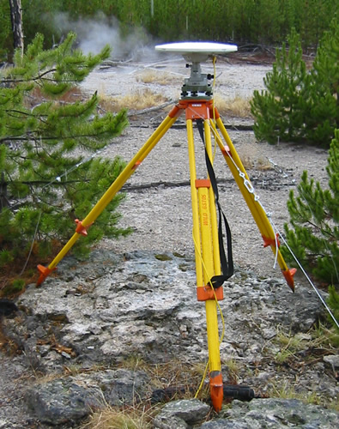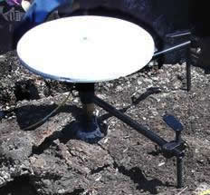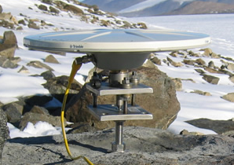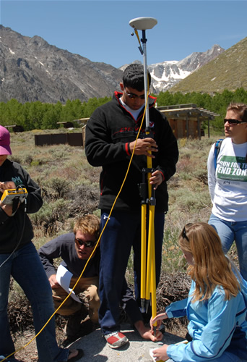
Figure 8: Examples of antenna mounts. (a) Standard tripods are bulky but are ideal for sites where the antenna must be elevated. (b) Fixed-height spike mounts are lightweight and highly portable; good for remote, open areas. (c) Fixed-height leveling mounts screw directly onto a threaded pin monument; highly portable and highly stable. (d) Bipods can be used for fast-static occupations or, by removing the legs, for kinematic surveys. Ideal for surveys with many survey marks within a small area.
For more detailed information, see http://facility.unavco.org/kb/questions/394/.
The antenna height above the survey monument in all cases must be recorded accurately for data archiving and processing. Antenna height is usually measured as either:
- Vertical – the vertical distance from the survey mark to the Antenna Reference Point, or ARP, which is typically the bottom surface of the antenna housing.
- Slant – the distance from the survey mark to the bottom edge of the antenna chokering or groundplane (tripods only) (Figure 9).
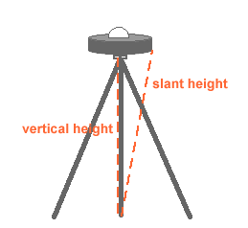
Figure 9: Measuring height on a chokering antenna.
Since a GPS antenna’s physical center and electronic center (phase center) may be different depending on variable factors such as satellite geometry, all antennas in a survey network should be oriented in the same direction to ensure that the measurements reflect the actual distance between monuments. Antennas are typically aligned to true (not magnetic) north. Many antennas are labeled with a north arrow; when they are not, the antenna cable connector is usually meant to be aligned to north. A magnetic declination calculator can be found online at http://www.ResurgentSoftware.com/GeoMag.html. Or, use an accurate map to determine true north and align the antennas with a compass accounting for the appropriate magnetic declination.
For antenna mount options available from UNAVCO, see http://facility.unavco.org/kb/questions/394/.

4. Receiver configuration

Receivers can be configured with either a computer, a survey controller (recommended for fast-static and kinematic surveys only), or, for some receiver models, through a LED screen.

Consider the following for your survey:

File length – do you want the receiver to bin the data into files of a fixed time window?
Sample rate – how often do you want the receiver to collect data? The base station (fast static and kinematic surveys) must collect data at least as often as the rover(s).
Elevation cutoff angle – data coming from low-elevation satellites is often noisy because of the atmosphere; from below what elevation do you want the receiver to discard, rather than store, the data? Note that these data can also be discarded during processing.

Typical file lengths, sample rates and elevation cutoffs:

Survey style | File length | Sample rate | Elevation cutoff angle
Continuous | 24 hr (UTC 0:00) | 30 seconds | 0 or 5 degrees
Static | 24 hr (UTC 0:00) | 30 seconds | 5 degrees
Rapid Static | none | 15 seconds | 13 degrees
Kinematic | none | 1-15 seconds | 13 degrees

There must be enough free memory in the receiver for the desired survey. Whereas memory is an issue with older receivers, the later generation receivers have large amounts of data storage. At a 15 s sample rate and 5 deg elevation mask, the Trimble 5700 and R7 receivers can log data for approximately 3 months onto a 128 MB compact flash card. Larger flashcards are also available. The Trimble NetRS logs the same file type to internal memory, which is commonly 1 GB of storage, yielding space for around 2 years of data collection. The Topcon GB-1000 file format is significantly larger than that of Trimble, producing an ~7 MB file for a 24-hr session collected at a 30 s sample rate. Both internal and external memory (a compact flashcard) of typically 1 GB each are available.

For information (specifications, how-tos, dealer information) on receivers available from UNAVCO, see http://facility.unavco.org/kb/questions/390/.

5. Power
Several options exist for powering a GPS receiver in the field. AC (outlet) power may be used when available, with battery back up in case of a power outage. Remote sites usually require battery power, and solar panels can be added to extend battery life or provide continuous power. The battery capacity and solar panels required depend on several factors, including survey period, receiver power consumption, charging options, weight limitations getting to the site, and amount of sunlight available. During field campaigns, charging batteries between sites is critical and must be factored in when planning field logistics unless the batteries are able to maintain sufficient charge from solar panels. AC battery chargers and solar panels are available from UNAVCO. Always double check battery capacity before leaving an unattended site.

UNAVCO provides rechargeable 12 Ah and 18 Ah batteries for field use. These batteries weigh 10 lbs and 15 lbs each, respectively. Battery capacity will vary depending on the condition of the individual battery, and will decrease at low temperatures and with battery age. UNAVCO also provides power cables that can be used with larger deep-cycle batteries to extend the receiver run time. Power draw on the receivers available for campaign use from UNAVCO is as follows, under ideal conditions:

Receiver | Power draw (approximate) | Time lasts on a 12 V, 18 Ah battery
Trimble NetRS | 3.5 W | 2.25 days
Trimble 5700 or R7 | 3-4 W | 2-2.5 days
Topcon GB1000 | 4 W | 1.9 days

For information on power options available from and testing performed by UNAVCO, see http://facility.unavco.org/kb/questions/524/.

POST-SURVEY

1. Data downloading and backup

Data collected with geodetic GPS receivers must be downloaded as soon after data collection as possible to free up receiver memory (if needed) and to back up the data. As a field precaution, a duplicate copy of the data should be made as soon as it is downloaded from the receiver. Data are typically downloaded to a laptop computer; to download a receiver, manufacturer-specific download software and procedures are usually required.

Downloading instructions depend on the equipment (receiver and/or survey controller) being used; see http://facility.unavco.org/kb/questions/390/.

Considerable expense goes into collecting geodetic quality GPS data, and the data should always be backed up as soon as possible to safeguard against loss, destruction, or corrupted media. While the particular data backup strategy may vary with logistics and personal preferences, there should always be three independent copies of all GPS data until it is confirmed that the data have been safeguarded in a data archive such as UNAVCO’s. Options for data storage prior to final archiving include CDs, PC memory cards, computer hard drives, and the GPS receiver memory. Before deleting any files from a GPS receiver, make sure they are adequately backed up elsewhere! A good practice is to keep copies of the data in separate locations and with different people.

2. Data formats

GPS receivers generally collect and store the raw GPS data in a proprietary format, which may need to be translated into a different format for data processing or data sharing. Later generation Trimble GPS receivers (5700, R7, NetRS) collect data in .T01 files, a format which must be translated to be read into Trimble’s processing software, Trimble Geomatics Office (TGO). These data are automatically translated to .DAT files, a Trimble format which can be read by TGO, when downloaded via the Trimble Data Transfer Utility. The Topcon GB-1000 collects data in a .tps file.

RINEX (Receiver Independent Exchange Format) is the ubiquitously accepted data format for raw GPS data. Reference site data (see section on Reference stations) are generally provided in RINEX. RINEX is read by most processing software, including Trimble Geomatics Office and Topcon Tools, and also more sophisticated processing software like Bernese, GAMIT, and GIPSY. Almost any raw high-precision GPS data can be converted to RINEX using teqc. Teqc (pronouced "tek") is a simple yet powerful and unified approach to solving many pre-processing problems with GPS, GLONASS, and SBAS data. The three main functions from which teqc gets its name—translation, editing, and quality check—can be performed altogether, in pairs, or separately. You can download teqc for free at http://facility.unavco.org/software/teqc/teqc.html.

While most raw data are stored as binary files, RINEX is in an ascii format and can therefore be viewed in a text editor. An example of a RINEX file is given below (Figure 10), and illustrates the information contained in raw GPS data files.

2.10 OBSERVATION DATA G (GPS) RINEX VERSION / TYPE
teqc 2004Oct27 UNAVCO Archive Ops 20041028 19:19:00UTCPGM / RUN BY / DATE
Solaris 2.7|Ultra 2|cc SC5.0|=+|*Sparc COMMENT
BIT 2 OF LLI FLAGS DATA COLLECTED UNDER A/S CONDITION COMMENT
P020 MARKER NAME
MARKER NUMBER
Mike Jackson UNAVCO OBSERVER / AGENCY
4413233095 TRIMBLE NETRS 0.7-0 REC # / TYPE / VERS
0220330167 TRM29659.00 SCIT ANT # / TYPE
-2083774.1380 -3827351.0369 4642283.4316 APPROX POSITION XYZ
0.0083 0.0000 0.0000 ANTENNA: DELTA H/E/N
1 1 WAVELENGTH FACT L1/2
6 L1 L2 C1 P2 S1 S2 # / TYPES OF OBSERV
15.0000 INTERVAL
RINEX file created by UNAVCO GPS Archive. COMMENT
For more information contact archive@unavco.org COMMENT
Monument ID: 00000000-18321-2004a COMMENT
UNAVCO 4-char name: P020 COMMENT
4-char name from Log or data file: P020 COMMENT
Monument location: 47.002209 -118.565769 480.1383 COMMENT
Visit ID: 76927 COMMENT
COMMENT
WSU_Dryland_Research_Station_Lind_WA_2004_CGPS COMMENT
COMMENT
End of DB comments COMMENT
SNR is mapped to RINEX snr flag value [0-9] COMMENT
L1 & L2: 2-19 dBHz = 1, 20-27 dBHz = 2, 28-31 dBHz = 3 COMMENT
32-35 dBHz = 4, 36-38 dBHz = 5, 39-41 dBHz = 6 COMMENT
42-44 dBHz = 7, 45-48 dBHz = 8, >= 49 dBHz = 9 COMMENT
2004 6 17 0 0 15.0000000 GPS TIME OF FIRST OBS
END OF HEADER
04 6 17 0 0 15.0000000 0 8G 1G 4G25G11G13G16G30G20
-3009032.38359 -2334639.62958 20726832.8364 20726820.9734
53.7504 46.0004
-3692368.30957 -2871796.35252 23958733.3914 23958722.8164
43.0004 22.2504
8468383.67659 6575277.72356 22094150.9694 22094139.1054
51.0004 40.0004
11821613.29356 9184820.42652 24814845.6094 24814834.4494
39.7504 21.2504
-6586713.07057 -5464689.84452 23734383.6954 23734372.0084
43.5004 25.2504
-7043354.68058 -5468882.80555 22454713.5394 22454701.2664
48.5004 36.7504
9647017.67655 7491528.96151 25227887.4304 25227876.7384
37.0004 14.7504
265471.93859 207372.30558 20246338.1564 20246325.4734
52.7504 48.0004
04 6 17 0 0 30.0000000 0 8G 1G 4G25G11G13G16G30G20
-3017172.37149 -2340982.47348 20725283.8594 20725271.8794
53.7504 46.0004
-3697743.72746 -2875984.98442 23957710.2814 23957700.3524
41.0004 23.5004
8517694.52749 6613701.75046 22103534.3524 22103522.6054
51.0004 39.7504
11881161.02046 9231221.22742 24826176.9454 24826165.9614
39.5004 21.2504
-6619885.39547 -5490538.40242 23728071.8204 23728059.6054
43.5004 27.2504
-7070702.28149 -5490192.60545 22449509.7424 22449497.2344
49.2504 37.2504
9704628.90245 7536420.81341 25238849.7894 25238839.7424
38.0004 17.7504
280861.96149 219364.52348 20249266.8444 20249253.9264

Figure 10: Sample RINEX file; *figure not finished*.
3. Data processing
GPS data collected for high precision applications (excluding data collected using RTK methods) must be post-processed to provide millimeter to meter level precision. Typically, the post-processing involves differential processing relative to a fixed base location. For certain survey types, such as stop-and–go kinematic, it is essential to process the data while still in the field as a data quality check. This allows for a re-survey if there are problems with the data. For more robust data collection methods such as static surveys, data processing in the field is not required. For many high accuracy applications final data processing in the field is not possible. Advanced data processing methods typically require internet access to continuous station data, precise satellite orbits, and on-line data processing services. A common process is to field process data as a quick quality check, then spend more time back in the office to rigorously develop the final results.

Post-processing the data accomplishes several things. First, there are numerous error sources in GPS positioning, the most significant of which are: Receiver and satellite clock errors, delay of the GPS signal through the Earth’s atmosphere (most significantly, the ionosphere and the troposphere), use of imprecise satellite orbits, and multipath (multiple signal arrivals resulting from the signal bouncing off nearby objects or the ground). Many of these errors can be greatly minimized or eliminated in post-processing by using data from at least two receivers with at least four satellites in common.

Different processing programs can serve different surveying needs. The following summarizes some of the options.

To obtain a position to within several cm of a static point where a very accurate position is not needed, several online services are available.

a. CSRS-PPP http://www.geod.nrcan.gc.ca/products-produits/ppp_e.php
CSRS PPP (Canadian Spatial Reference System - Precise Point Positioning) is a flexible service which offers both static and kinematic data processing. Access to the database is free but requires a username and password. Data files can be uploaded directly to the site.

b. OPUS http://www.ngs.noaa.gov/OPUS/
A data file of at least two hours is recommended. Data files can be uploaded directly to the site.

c. AusPos http://www.ga.gov.au/geodesy/sgc/wwwgps/
Data files can be uploaded directly to the site.

d. APPS http://apps.gdgps.net/
A JPL service that replaces AutoGIPSY. Data files can be uploaded directly to the site.

For cm-level static or kinematic surveys with short (ideally < 10 km) baselines, commercially available software (e.g. TGO, Topcon Tools) is often adequate. See http://facility.unavco.org/project_support/campaign/documentation/TGO.pdf for a how-to on TGO.

For highest precision (sub-cm) surveys and most surveys including long baselines (> 50 km), a more sophisticated software package is required. Several software packages to process precise GPS data for research applications have been developed by different international research groups. The availability of executable code, documentation, and user support varies with the individual development group.
a. GAMIT/GLOBK http://www-gpsg.mit.edu/~simon/gtgk/index.htm
GAMIT and GLOBK are a comprehensive suite of programs for analyzing GPS measurements primarily to study crustal deformation. The software has been developed by MIT, Scripps Institution of Oceanography, and Harvard University with support from the National Science Foundation. GAMIT/GLOBK may be obtained without written agreement or royalty fee by individuals, universities, and government agencies for any non-commercial purposes.

b. Bernese http://www.cx.unibe.ch/aiub/bernese.html
Bernese software was developed at the Astronomisches Institut der Universität Bern in Bern, Switzerland. A license is needed to use the software.

c. GIPSY-OASIS http://gipsy.jpl.nasa.gov/orms/goa/
GIPSY-OASIS (GOA II) software was developed and is supported by NASA’s Jet Propulsion Laboratory (JPL). The software is available with a no-fee license to members of the international research community.

Additional helpful processing resources include the following:

Several organizations provide precise satellite orbital information which is calculated daily and available with a two-week delay. The application of this information (rather than the orbital information broadcast by the satellites) can improve precision of ground coordinate solutions. Examples of places to find precise orbital information, generally available in files appended .SP3, are:
SOPAC http://sopac.ucsd.edu/cgi-bin/dbDataByDate.cgi?defaultType=products
IGS http://igscb.jpl.nasa.gov/components/prods_cb.html

NIMA EGM96 Geoid Calculator, to calculate the geoid-ellipsoid separation at any given point: http://earth-info.nga.mil/GandG/wgs84/gravitymod/egm96/intpt.html

NGS Reference Frame Transformation, to translate coordinates from one reference frame to another: http://www.ngs.noaa.gov/cgi-bin/HTDP/htdp.prl?f1=4&f2=1

Also, see the section on Reference Stations for links to data from continuous GPS sites.

4. Data archiving and data access
As a service to the geodetic community, the UNAVCO Boulder Facility Archive manages, stores, and provides access to high-precision GPS geodetic data. The archive will also accept non-geodetic GPS data projects (e.g. mapping). The data stored are primarily collected on research projects sponsored by the National Science Foundation (NSF) and National Aeronautics and Space Administration (NASA). Please contribute to the Boulder Facility Archive immediately after campaign completion to best preserve time-sensitive information. Most data must be archived within six months of data collection. See the UNAVCO GPS Data Policy for more information: http://www.unavco.org/community/policies_forms/DataPolicy.html.

To archive project data, fill out a project support request form if you have not already done so for your project: http://achaia.unavco.org/public/newproject/supportform.aspx.

Prepare legible copies of site descriptions and logsheets (e.g. Monument Record forms and Site Visit Logsheets) and any other pertinent material (photos etc.) to accompany data. At the very least, the archive needs the site name, antenna height, antenna height measurement method (e.g. slant), antenna mount type, and antenna and receiver models and serial numbers; this is the minimum information needed to meaningfully process the GPS data.

Data should be submitted in raw format if possible. Data may additionally be submitted in a translated format.

Coordinate submissions with the UNAVCO Data Management and Archiving Group: archive@unavco.org. Submissions can be mailed/shipped or dropped off via ftp (preferred) for the archive. For more details, look up Submissions on the UNAVCO Facility Data page: http://facility.unavco.org/data/data.html.

UNAVCO Data Management and Archiving Group mail/shipping address:
Attn: Boulder Facility Archive
UNAVCO
6350 Nautilus Drive
Boulder, CO 80301

If submitting data and metadata (accompanying information) via ftp, a directory will be assigned to you.

To access both campaign and permanent station data, check out our interactive Data Archive Interface, the DAI2 (Figure 11): http://www.unavco.org/community/policies_forms/DataPolicy.html. Search for data by station name, marker name, campaign name, or geographical region. For a brief tutorial, see the Help feature at the top of the page (you may have to widen your browser window to see the Help option).

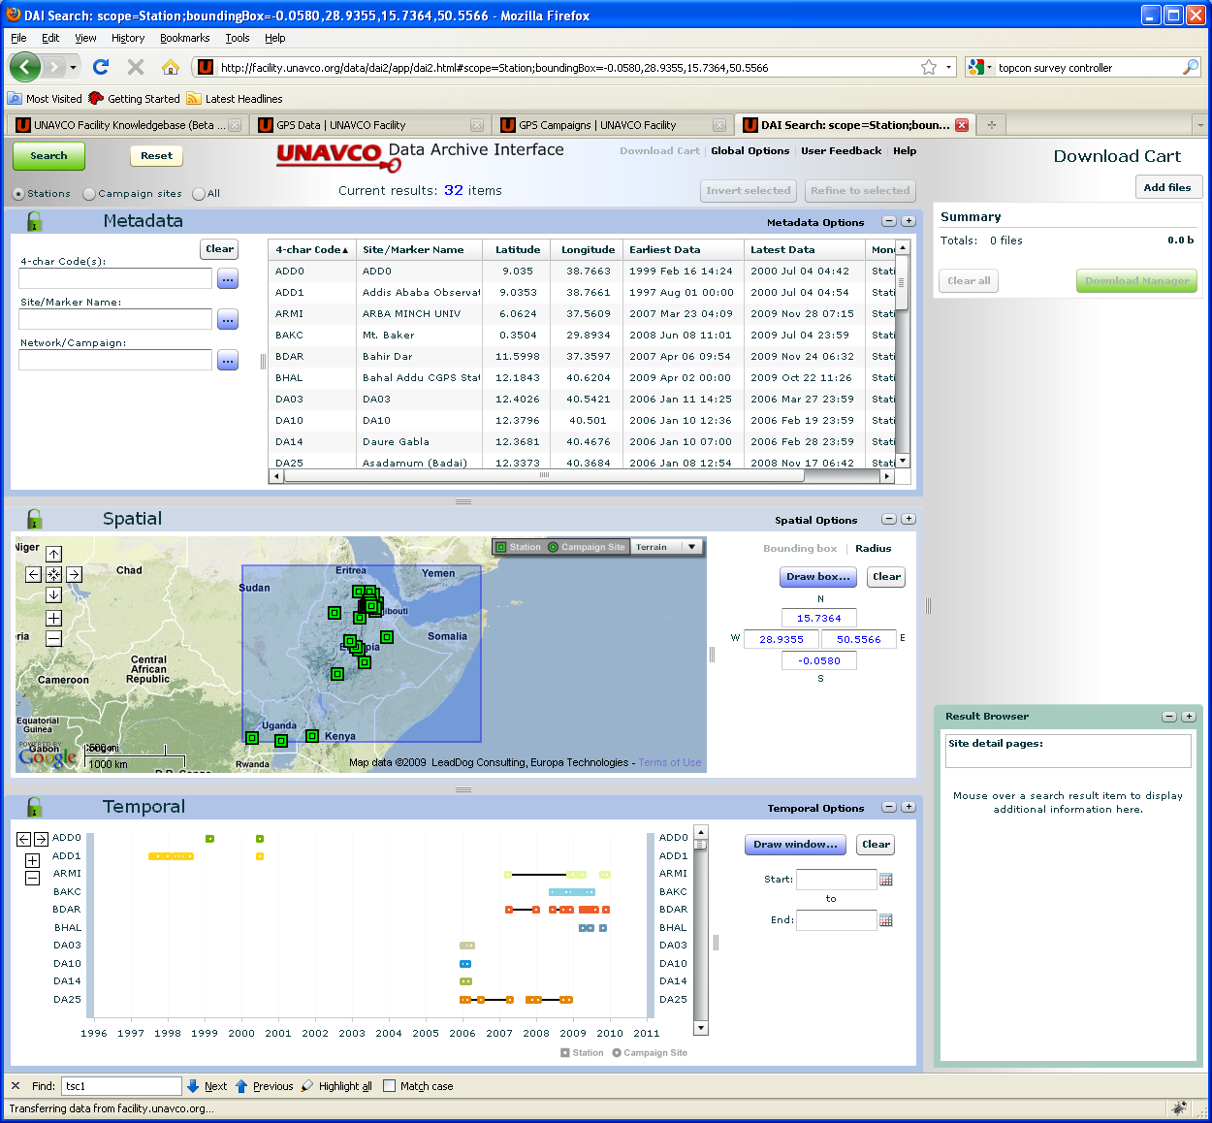
Figure 11: Screenshot of the DAI2, UNAVCO’s Data Archive Interface. Search for data by four-character code, site/marker name, network or campaign, or by geographical region. View metadata, operational history, and station health and time series where available.
WORKING WITH UNAVCO

UNAVCO is a non-profit membership-governed consortium funded through the National Science Foundation (NSF) and National Aeronautics and Space Administration (NASA). UNAVCO’s mission is to support and promote high-precision measurement techniques for the advancement of Earth sciences. Member organizations are primarily research universities who study deformation of the Earth’s crust, addressing mechanisms for large and small scale tectonic features and processes, such as earthquakes, volcanoes, plate motion, faulting and folding, and mountain building.

UNAVCO provides a variety of support options, including equipment loans, field support, budgeting, consultation, training, and data archiving. Request support through the On-line Support Request Form at:

http://achaia.unavco.org/public/newproject/supportform.aspx.

Useful Links

UNAVCO website: http://www.unavco.org

About UNAVCO: http://www.unavco.org/aboutus/aboutus.html

UNAVCO Resources: Campaign and Kinematic GPS/GNSS: http://facility.unavco.org/project_support/campaign/campaignGNSS.html

